
KONERU LAKSHMAIAH EDUCATION FOUNDATION
(Deemed to be University estd, u/s, 3 of the UGC Act, 1956) Green Fields, Guntur District, A.P., India – 522502
Department of Electronics and Communication Engineering
(DST - FIST Sponsored Department)
Course Code: 24SDEC01R Program: B.Tech - ECE
Course Title: ELECTRONIC SYSTEM DESIGN Academic Year: 2025-26-II/IV-II Sem

SKILL EXPERIMENTS RESULTS :
STUDENT NAME: Y. Harshavardhan STUDENT ID: 2400040454
EXP. No.: 10 DATE:

TITLE OF THE EXPERIMENT: Designing an ON and OFF Timer Circuit: PCB Artwork

AIM: : To design and implement a PCB for an ON and OFF timer circuit using
EasyEDA, To design a circuit that can control the ON and OFF timing of a load using a 555
timer IC..

COMPONENTS REQUIRED:
EasyEDA software
A computer with an internet connection
A schematic of the ON and OFF Timer circuit

CIRCUIT DIAGRAM:
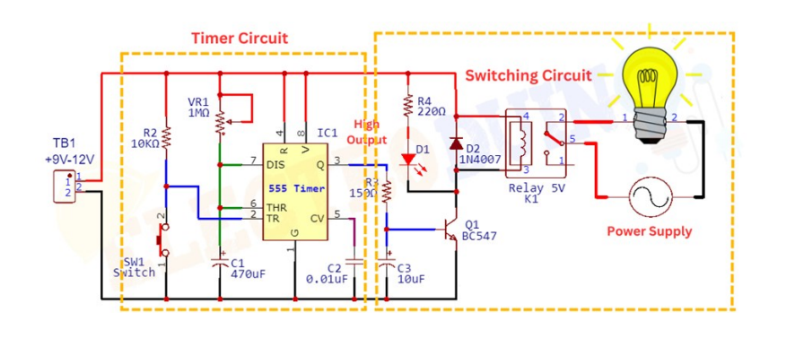

SCHEMATIC:
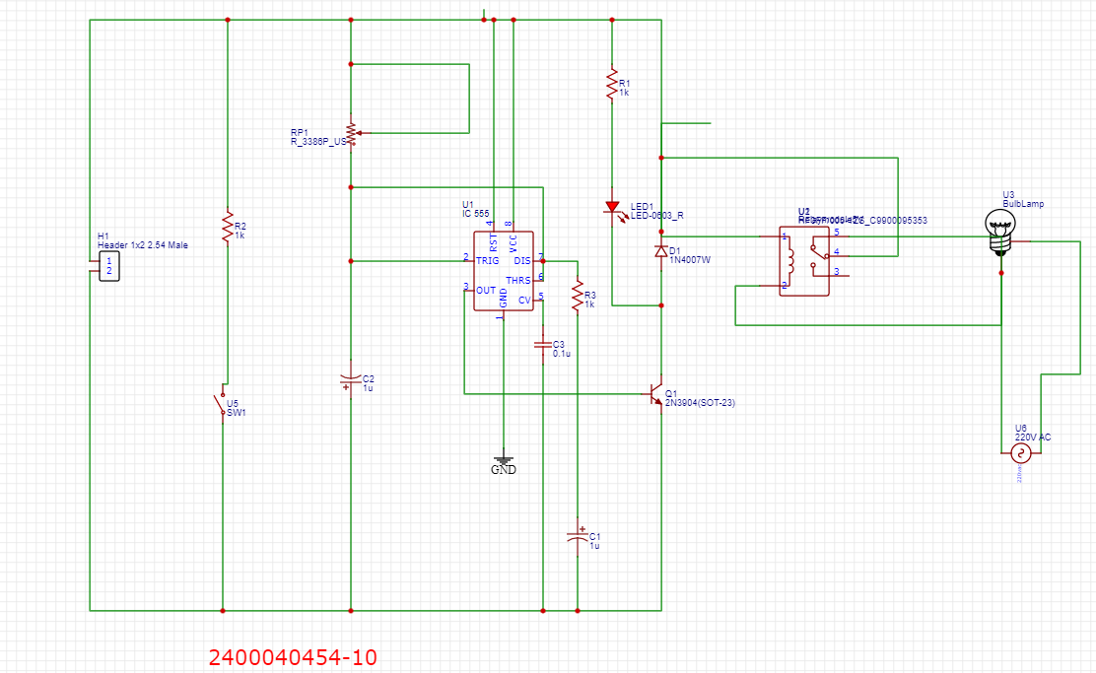

PCB LAYOUT:
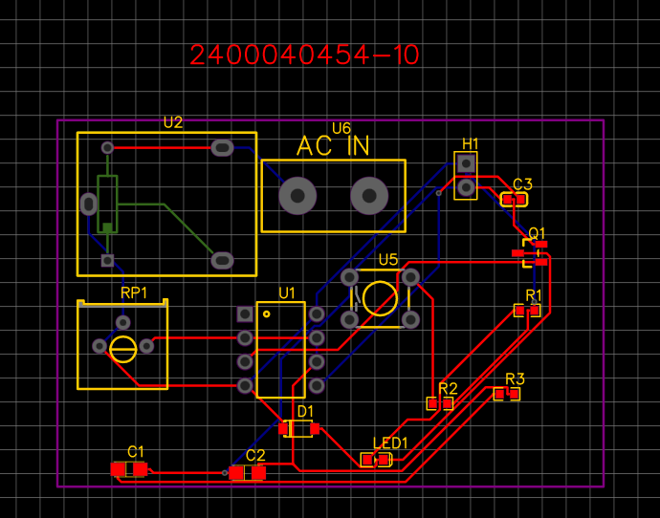
2D VIEW:
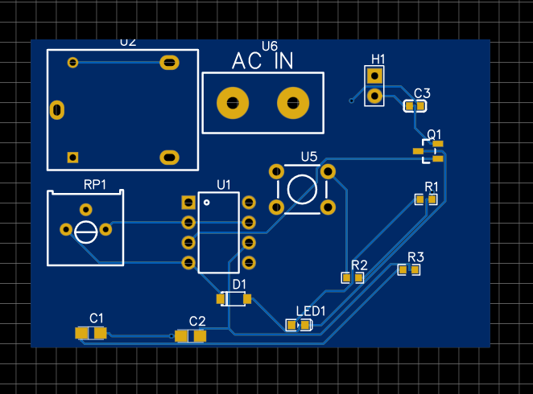

3D VIEW:
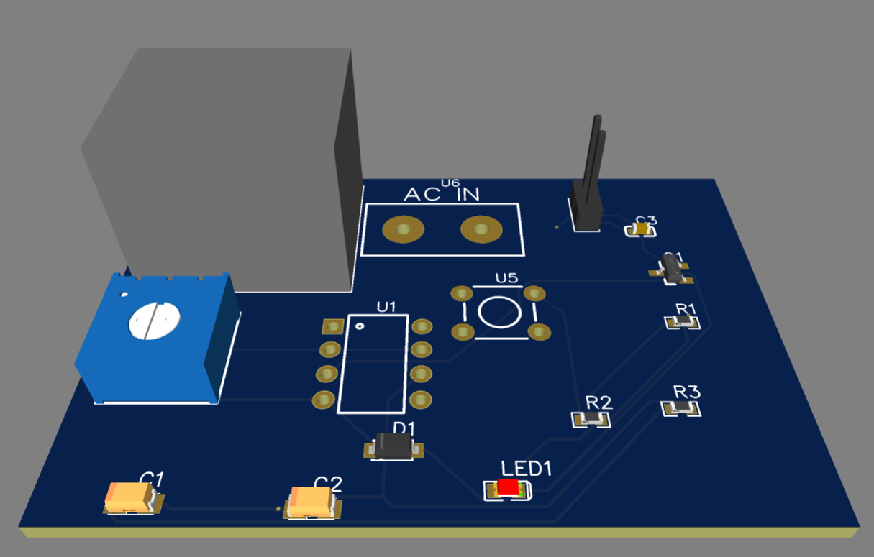d.

